Appendix 4. Data Flow Diagram

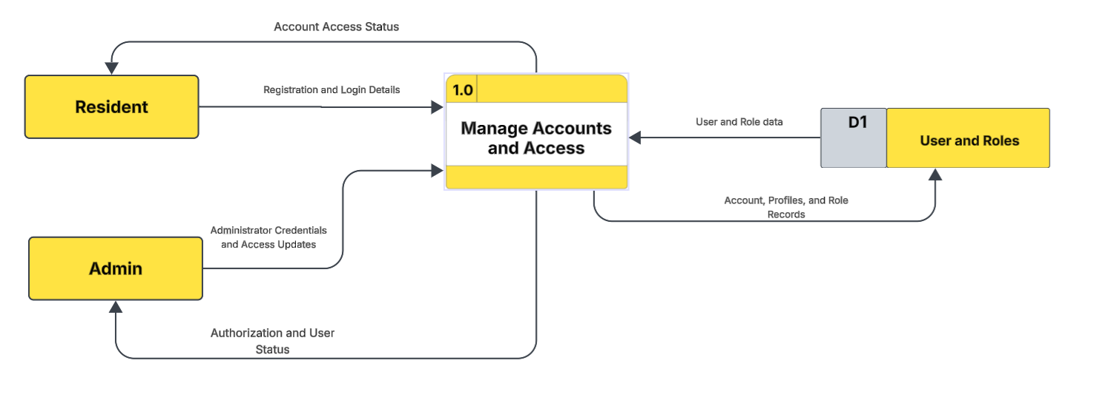

Appendix Figure 1. Data Flow Diagram Level 1 of FloodSense: An Android-Based Expert System for Flood Susceptibility Assessment and Pre-Event Preparedness in Bacoor City

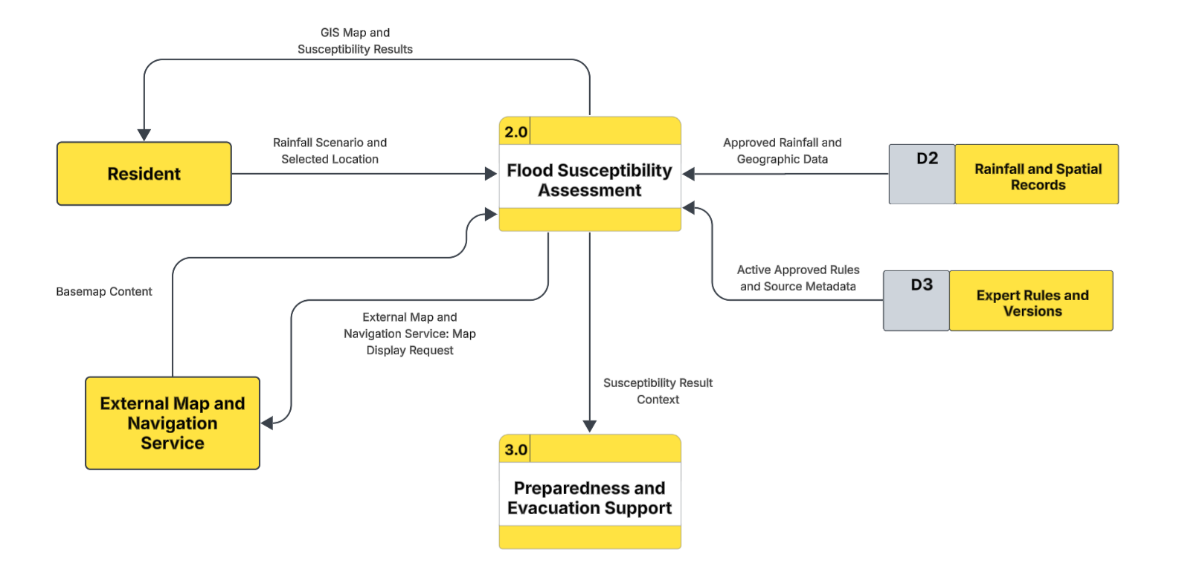

Appendix Figure 2. Data Flow Diagram Level 1 of FloodSense: An Android-Based Expert System for Flood Susceptibility Assessment and Pre-Event Preparedness in Bacoor City

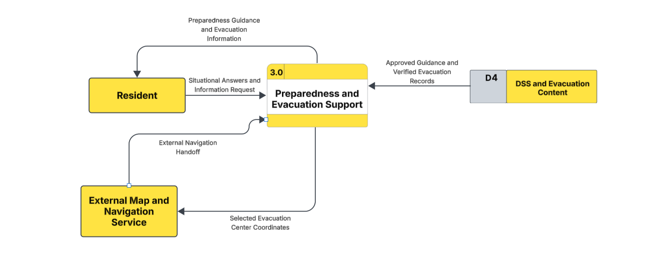
Appendix Figure 3. Data Flow Diagram Level 1 of FloodSense: An Android-Based Expert System for Flood Susceptibility Assessment and Pre-Event Preparedness in Bacoor City

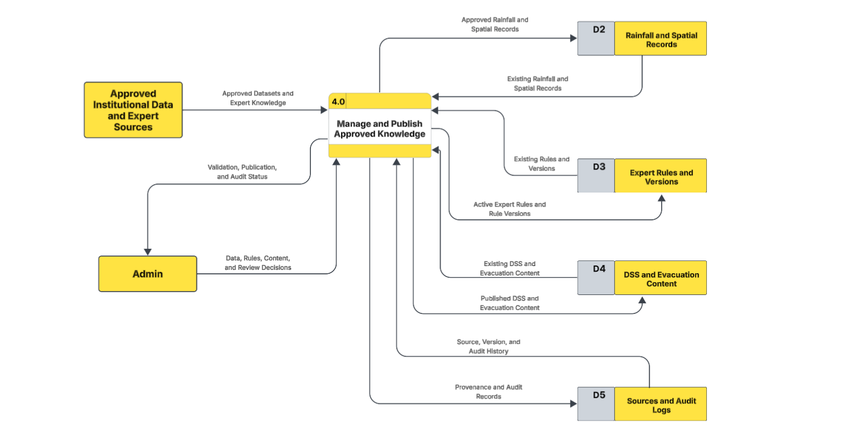
Appendix Figure 4. Data Flow Diagram Level 1 of FloodSense: An Android-Based Expert System for Flood Susceptibility Assessment and Pre-Event Preparedness in Bacoor City

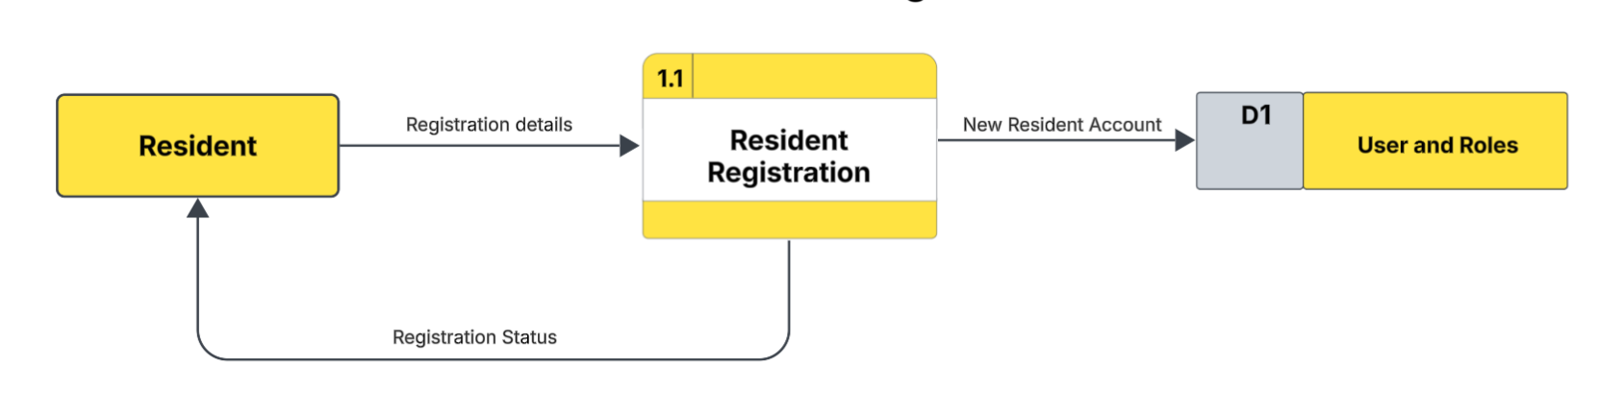

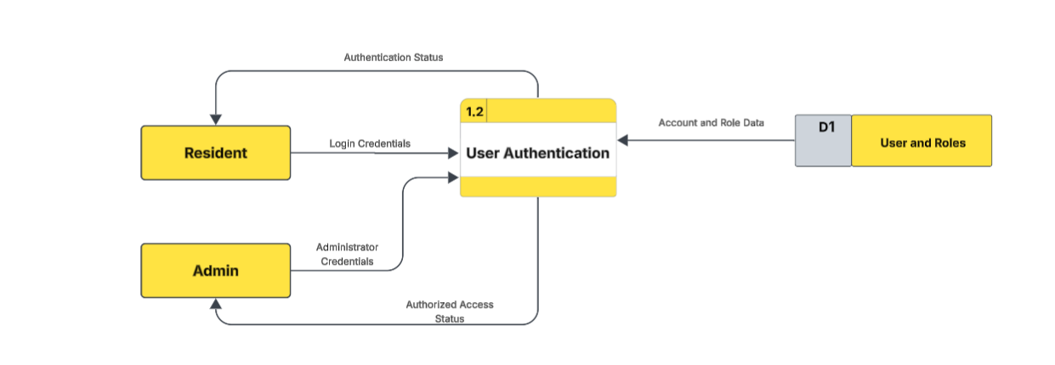

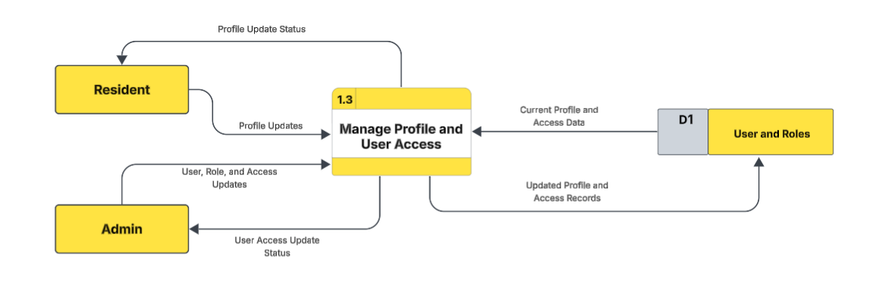
Appendix Figure 5. Data Flow Diagram Level 2: Process 1.0 of FloodSense: An Android-Based Expert System for Flood Susceptibility Assessment and Pre-Event Preparedness in Bacoor City

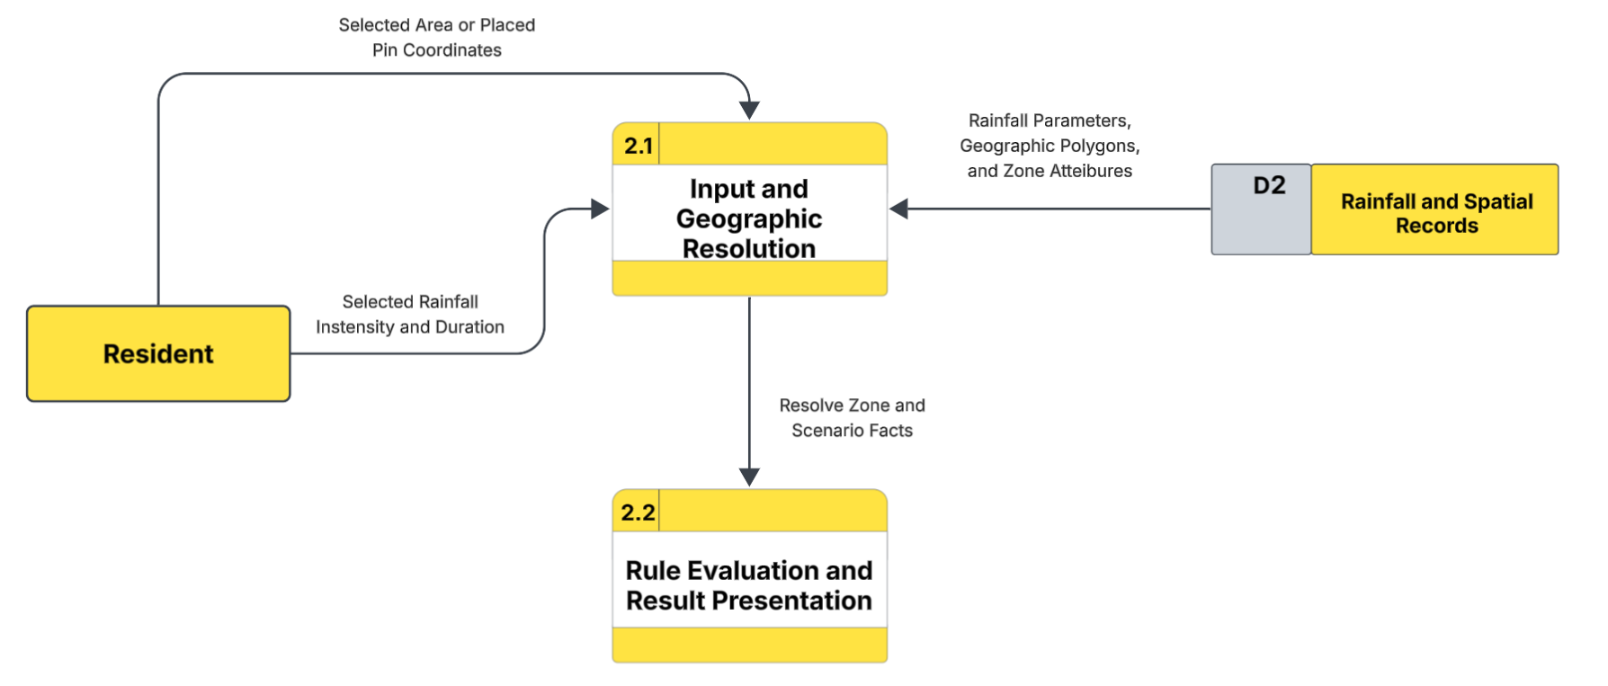
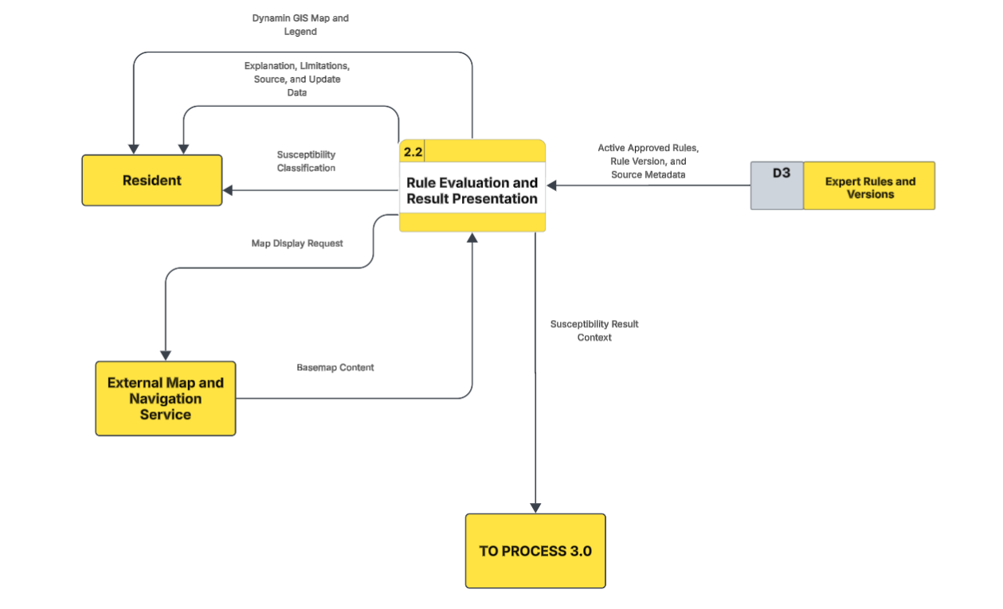
Appendix Figure 5. Data Flow Diagram Level 2: Process 2.0 of FloodSense: An Android-Based Expert System for Flood Susceptibility Assessment and Pre-Event Preparedness in Bacoor City

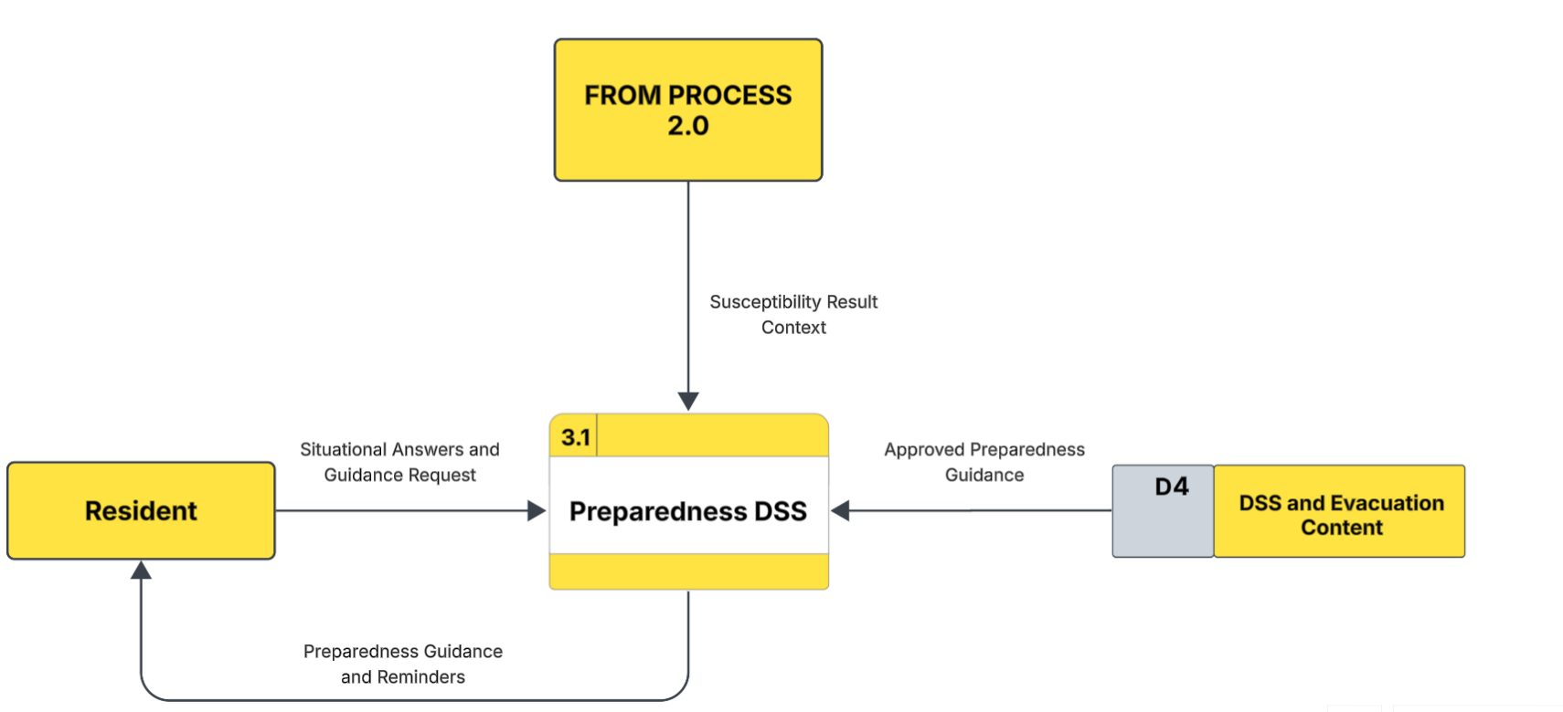

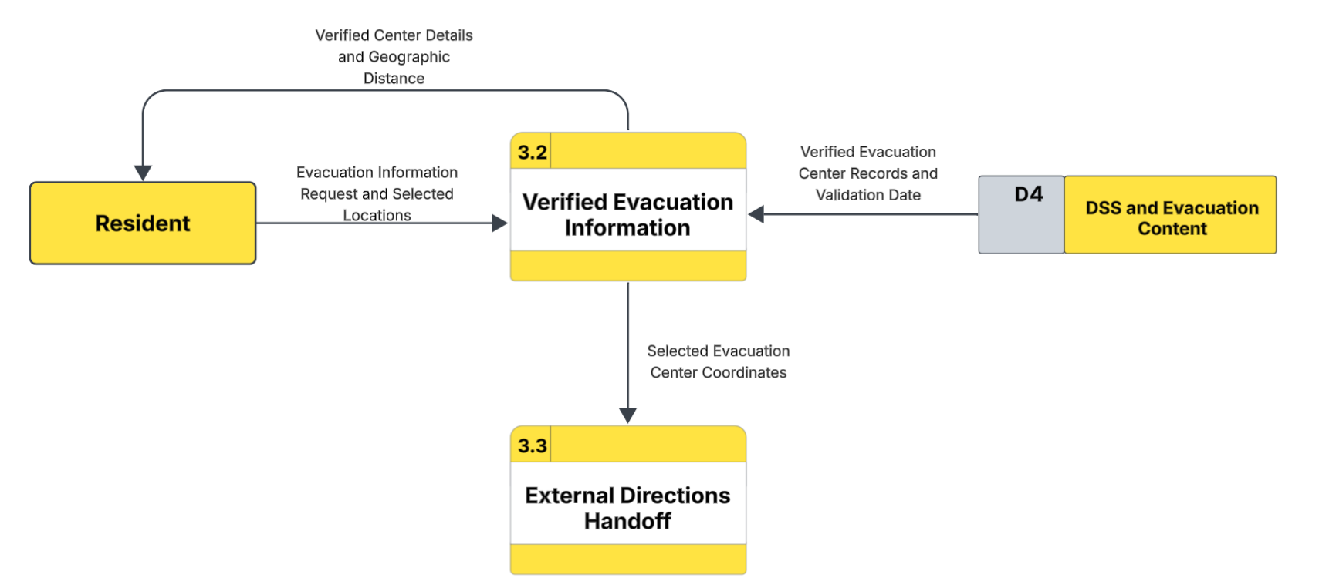

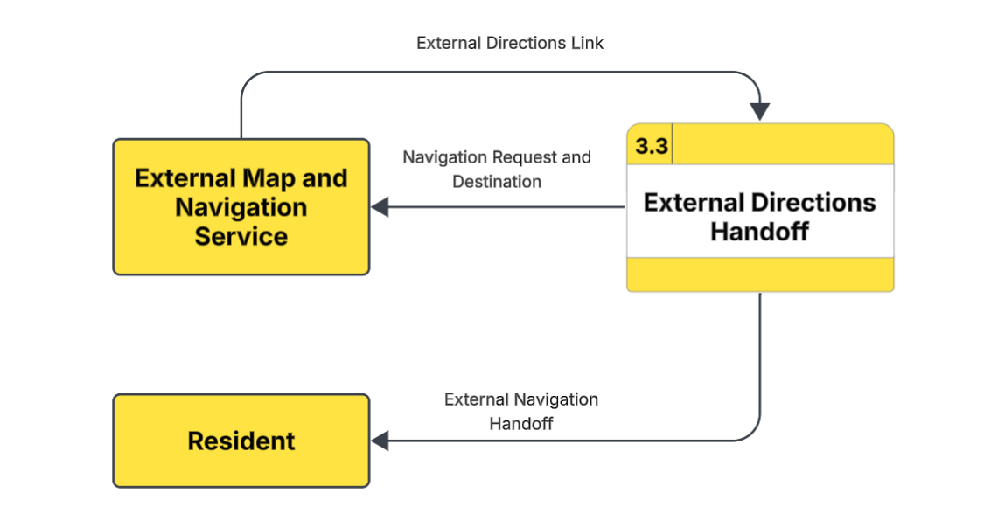
Appendix Figure 5. Data Flow Diagram Level 2: Process 3.0 of FloodSense: An Android-Based Expert System for Flood Susceptibility Assessment and Pre-Event Preparedness in Bacoor City

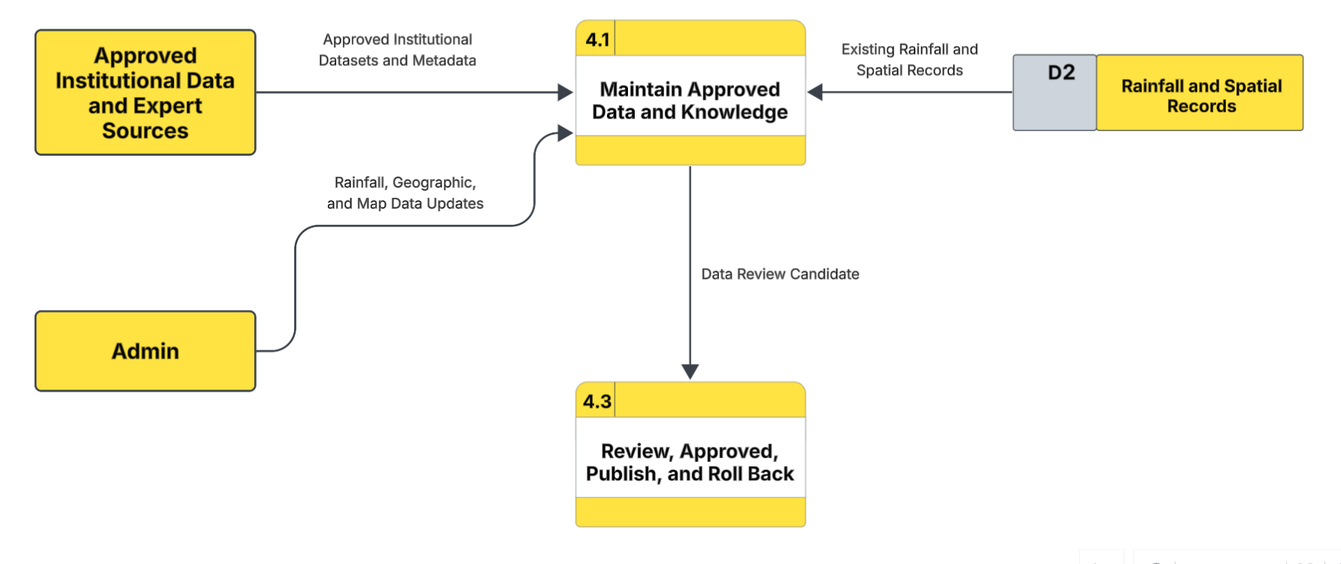

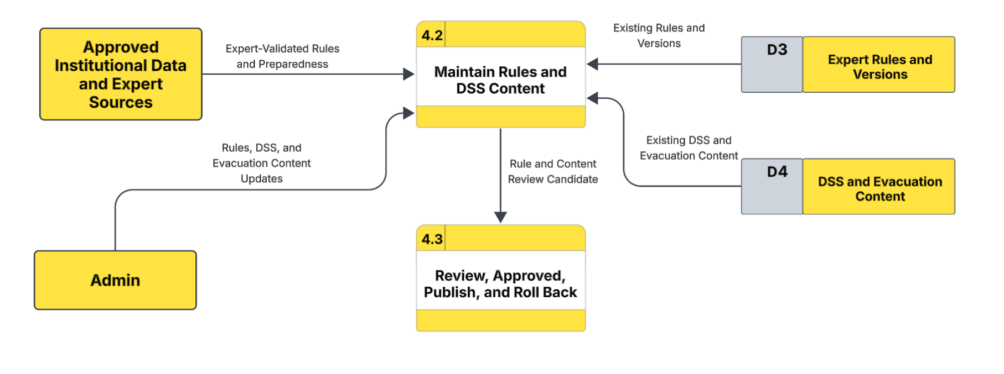

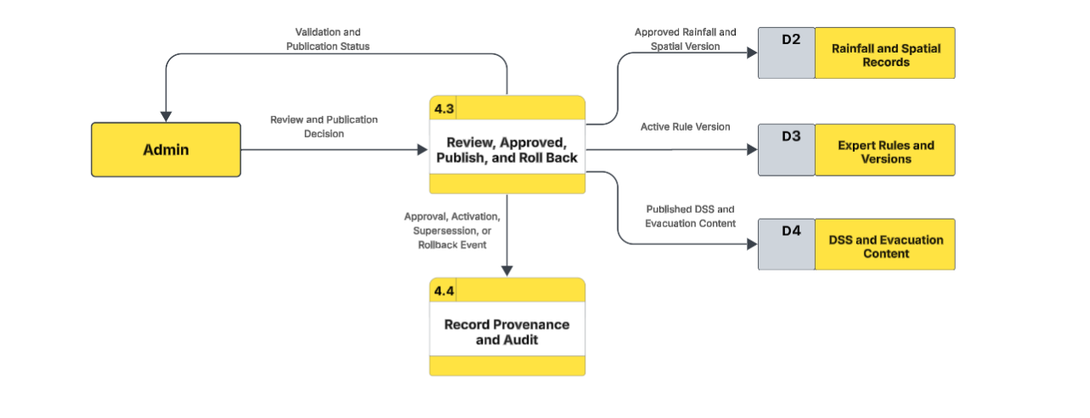

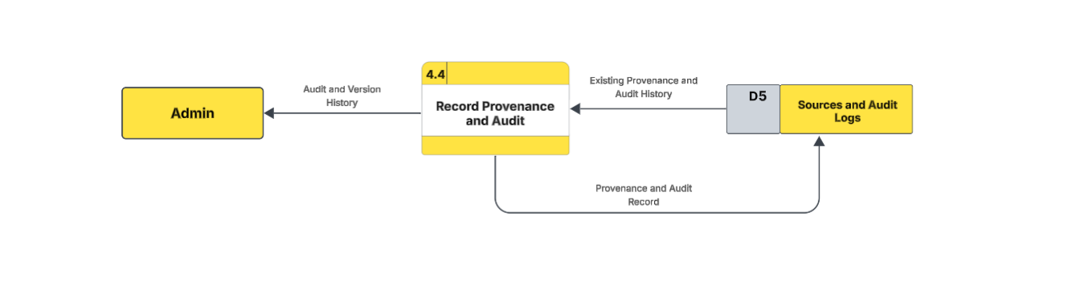

Appendix Figure 5. Data Flow Diagram Level 2: Process 4.0 of FloodSense: An Android-Based Expert System for Flood Susceptibility Assessment and Pre-Event Preparedness in Bacoor City

